

**Green University of Bangladesh**

**Department of Computer Science and Engineering (CSE)**

**Semester: (Spring, Year:2024), B.Sc. in CSE (Day)**

**Lab Report NO #01**

**Course Title: Data Communication Lab**

**Course Code: CSE 308 Section: 221 D20**

**Lab Experiment Name: Implementing Bit & Caracter Stuffing and De-stuffing.**

**Student Details**

| **Name** | | **ID** |
| --- | --- | --- |
| **1.** | Tanvir Ahmed | 221002461 |

**Lab Date : 12/3/2024**

**Submission Date : 16/3/2024**

**Course Teacher’s Name : Md. Romazan Alom**

| **Lab Report Status**  **Marks: ………………………………… Signature:.....................**  **Comments:.............................................. Date:..............................** |
| --- |

**Introduction:**

Here we have two tasks, message stuffing and distuffing. We use Stuffing and Distuffing for message transmission to provide extra security that ensures no one can access our message without our permission. In the task, we have a character stuffing di-stuffing and a bit stuffing di-stuffing. If we have ABC in the message we replace it with CBA. Doing this we add some security to ensure that no one can read our message. Although only three character change is not enough to modify the message, here we use only three characters for education purposes. I added ‘abc’ also to the task. On the other hand, in bit stuffing di-stuffing if we have 101 in the message we add an extra 0 to the message(1010). Let’s implement.

**Problem 1:**

Source code:

#**include** <stdio.h>

void **stuff**(char str[100]){

char st[100];

int i;

**for**(i =0; str[i] != '\0'; )

{

**if** (str[i] == 'A' && str[i + 1] == 'B' && str[i + 2] == 'C')

{

st[i] = 'C';

st[i + 1] = 'B';

st[i + 2] = 'A';

i += 3;

}

**else** **if** (str[i] == 'a' && str[i + 1] == 'b' && str[i + 2] == 'c')

{

st[i] = 'c';

st[i + 1] = 'b';

st[i + 2] = 'a';

i += 3;

}

**else**

{

st[i] = str[i];

i++;

}

}

st[i] = '\0';

printf("Stuffing: %s\n", st);

}

void **de_stuff**(char str[100]){

char dst[100];

int i;

**for**(i=0; str[i] != '\0';)

{

**if** (str[i] == 'C' && str[i + 1] == 'B' && str[i + 2] == 'A')

{

dst[i] = 'A';

dst[i + 1] = 'B';

dst[i + 2] = 'C';

i += 3;

}

**else** **if** (str[i] == 'c' && str[i + 1] == 'b' && str[i + 2] == 'a')

{

dst[i] = 'a';

dst[i + 1] = 'b';

dst[i + 2] = 'c';

i += 3;

}

**else**

{

dst[i] = str[i];

i++;

}

}

dst[i] = '\0';

printf("De-stuffing: %s\n", dst);

}

int **main**()

{

char choice[1];

char str[100];

printf("1: Stuffing."

"2: De-Stuffing."

"Enter 1/2:");

scanf("%s", choice);

**if** (choice[0] == '1'){

printf("Enter String for Stuffing: ");

scanf("%s", str);

stuff(str);

}

**else** **if** (choice[0] == '2'){

printf("Enter String for De-Stuffing: ");

scanf("%s", str);

de_stuff(str);

}

**else**{

printf("Wrong input.");

}

}

output:

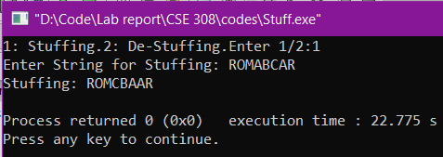

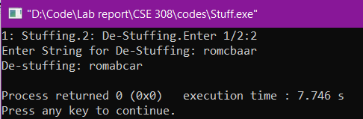

**Problem 2:**

Source code:

#**include** <stdio.h>

void **stuff**(char str[100]){

char st[100];

int i;

**for**(i =0; str[i] != '\0'; )

{

**if** (str[i] == 'A' && str[i + 1] == 'B' && str[i + 2] == 'C')

{

st[i] = 'C';

st[i + 1] = 'B';

st[i + 2] = 'A';

i += 3;

}

**else** **if** (str[i] == 'a' && str[i + 1] == 'b' && str[i + 2] == 'c')

{

st[i] = 'c';

st[i + 1] = 'b';

st[i + 2] = 'a';

i += 3;

}

**else**

{

st[i] = str[i];

i++;

}

}

st[i] = '\0';

printf("Stuffing: %s\n", st);

}

void **de_stuff**(char str[100]){

char dst[100];

int i;

**for**(i=0; str[i] != '\0';)

{

**if** (str[i] == 'C' && str[i + 1] == 'B' && str[i + 2] == 'A')

{

dst[i] = 'A';

dst[i + 1] = 'B';

dst[i + 2] = 'C';

i += 3;

}

**else** **if** (str[i] == 'c' && str[i + 1] == 'b' && str[i + 2] == 'a')

{

dst[i] = 'a';

dst[i + 1] = 'b';

dst[i + 2] = 'c';

i += 3;

}

**else**

{

dst[i] = str[i];

i++;

}

}

dst[i] = '\0';

printf("De-stuffing: %s\n", dst);

}

int **main**()

{

char choice[1];

char str[100];

printf("1: Stuffing."

"2: De-Stuffing."

"Enter 1/2:");

scanf("%s", choice);

**if** (choice[0] == '1'){

printf("Enter String for Stuffing: ");

scanf("%s", str);

stuff(str);

}

**else** **if** (choice[0] == '2'){

printf("Enter String for De-Stuffing: ");

scanf("%s", str);

de_stuff(str);

}

**else**{

printf("Wrong input.");

}

}

output:

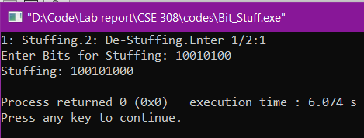

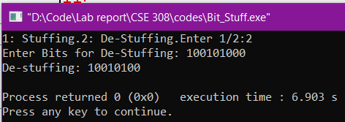

**Discussion:**

We have completed both tasks properly, and the outputs of both problems tested correctly. I took some help from the lab manual to complete the tasks. The second task was easy for me, I just edited certain points and it came out perfect. But the first problem was a little difficult and time-consuming for me because I wrote program on C after a long time. That’s why I need some recall of C functionalities first. Although I completed the tasks properly I guess, I didn’t find any error in the final output.